***RIPHAH INTERNATIONAL UNIVERSITY GCC CAMPUS***

|  |  |  |  |  |
| --- | --- | --- | --- | --- |
| **NAME** | **SAP** | **DEP** | **COURSE** | **LAB** |
| **TEHREEM IJAZ** | **62688** | **FC** | **BSCS** | **09** |

**Q .01 C++ program that uses an array to prompt the user to input three integer values and prints these values in both forward and reversed order.**

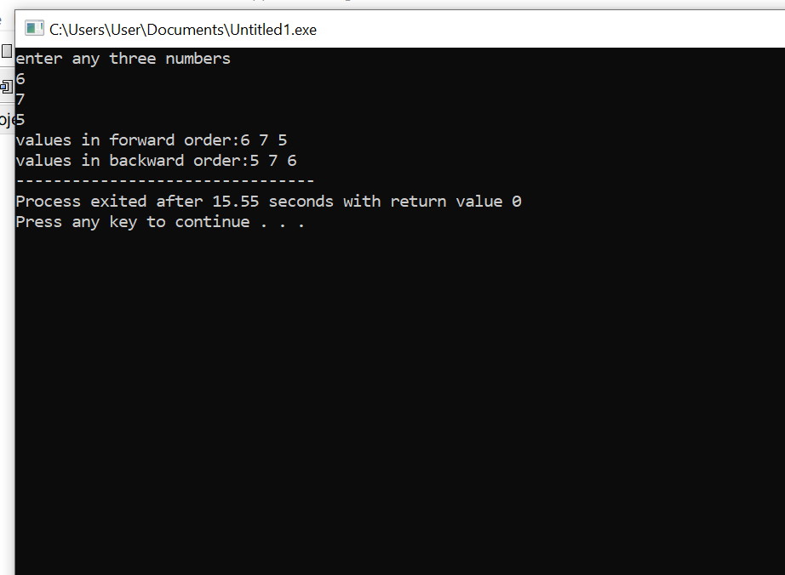

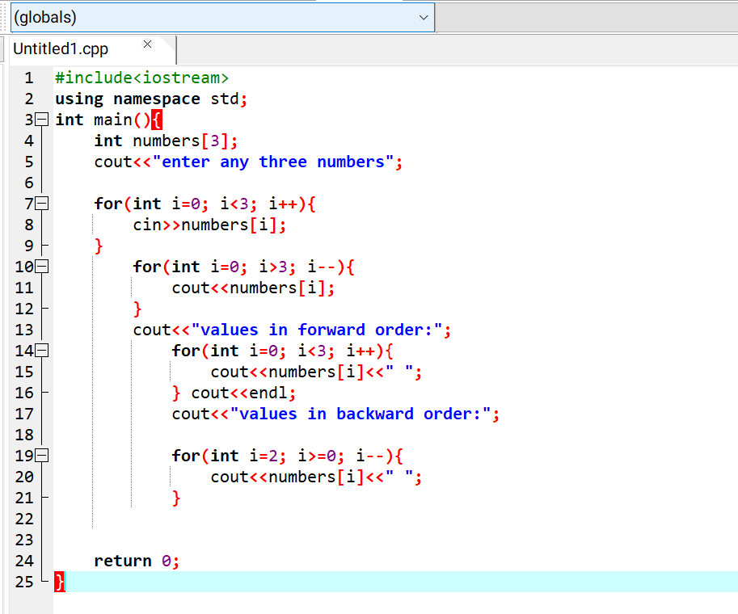

**Create a program in C++ that reads a square matrix (2D array) of size N x N from the user and outputs its transposed version.Hint: Transpose is shifting rows into cols and cols into rows**

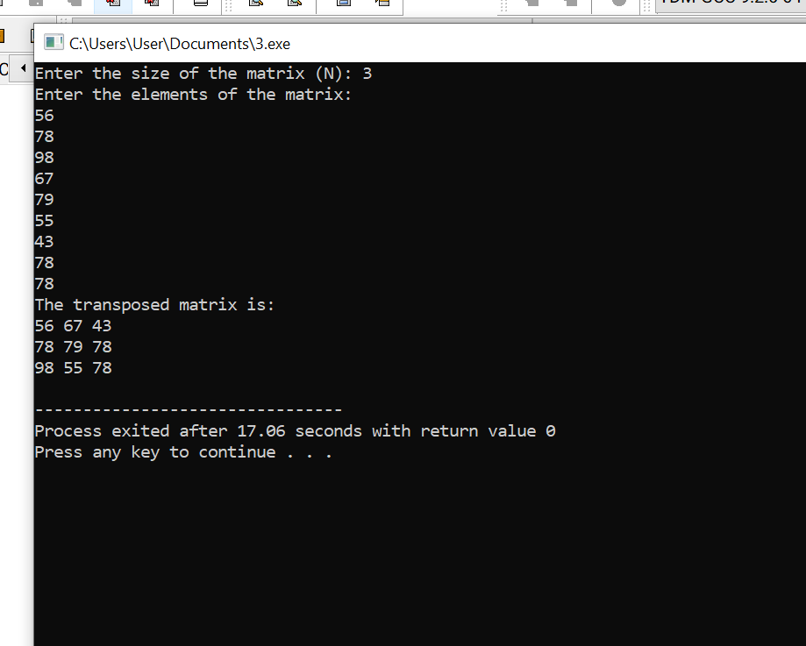

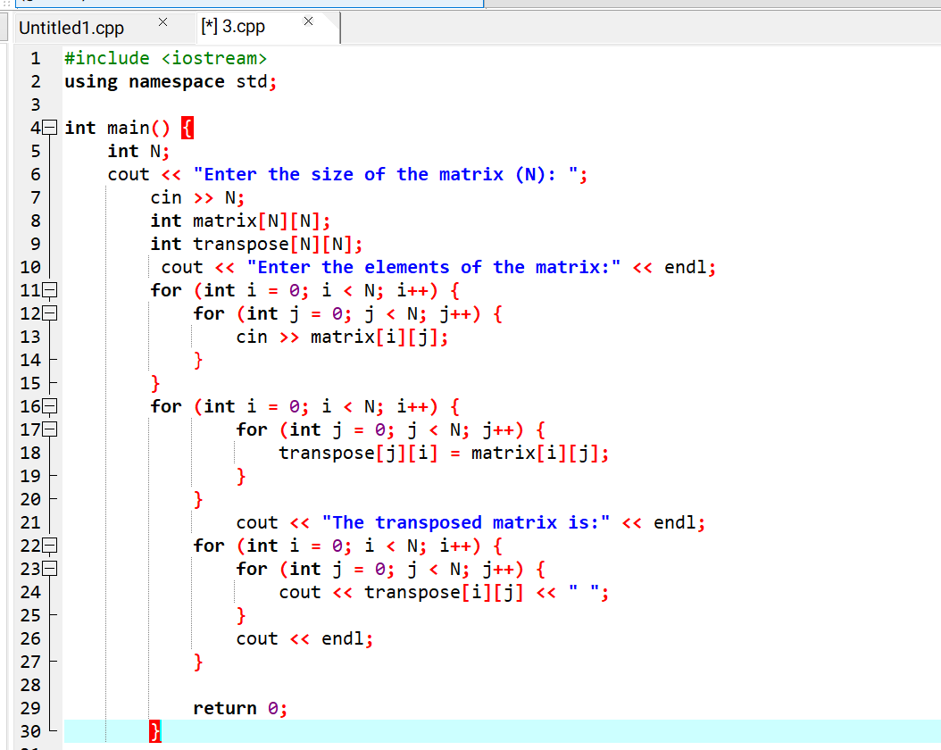

**Qs no .3 Scenario: *Organizing a Qawali Night* Event**

Imagine you are organizing a Qawali night event for the first-semester students in your college. You want to gather information about the students who are interested in attending the event. You decide to use a simple program to collect the names of the interested students and calculate the ticket price and popcorn price.

Here's how the scenario plays out:

**Program Start:**

Initialize two variables **ticketPrice and popcornPrice** to represent the cost of a ticket and popcorn, respectively

The program starts by asking, "How many users attend the event ”? (Maximum 10): "

You enter the number of students who want to attend the Qawali night.

**User Input For Loop:**

The program then enters a loop where it asks for the name of each student one by one.

For example, it might display: "Enter name for user 1: "

You input the name of the first student and continue until all names are entered.

Display User Names:

After collecting all the names, the program displays the entered names in the format:

**For Example**

User names for the event:

User 1: [Name1]

User 2: [Name2]

...

**Maximum Users Check:**

If you try to input more users than the maximum allowed (10 in this case), the program displays an error message: "Error: Not more users allowed."

**Display User Names and Total Cost:**

Inside the loop, The program then calculates the total cost for each user (ticket price + popcorn price) and displays it along with the user's name. Finally, it calculates and displays the total cost for all users. **You can adjust the ticketPrice and popcornPrice values according to your requirements.**

**Display Total Cost:**

After the loop, it displays the total cost for all users. (ticket price + popcorn price).

**Program End:**

The program ends, and you have successfully gathered the names of students interested in the movie night event and tatal cost of ticket and popcorn .

**solution**

#include <iostream>

#include <string>

#include <vector>

using namespace std;

int main() {

const int ticketPrice = 300;

const int popcornPrice = 150;

int numberOfUsers;

cout << "How many users will attend the event? (Maximum 10): ";

cin >> numberOfUsers;

if (numberOfUsers > 10) {

cout << "Error: Not more than 10 users are allowed." << endl;

return 1;

}

vector<string> userNames(numberOfUsers);

for (int i = 0; i < numberOfUsers; i++) {

cout << "Enter name for user " << i + 1 << ": ";

cin >> userNames[i];

}

int totalCost = 0;

cout << "\nUser names for the event:\n";

for (int i = 0; i < numberOfUsers; i++) {

int userCost = ticketPrice + popcornPrice;

totalCost += userCost;

cout << "User " << i + 1 << ": " << userNames[i]

<< " | Total Cost: Rs. " << userCost << endl;

}

cout << "\nTotal cost for all users: Rs. " << totalCost << endl;

return 0;

}

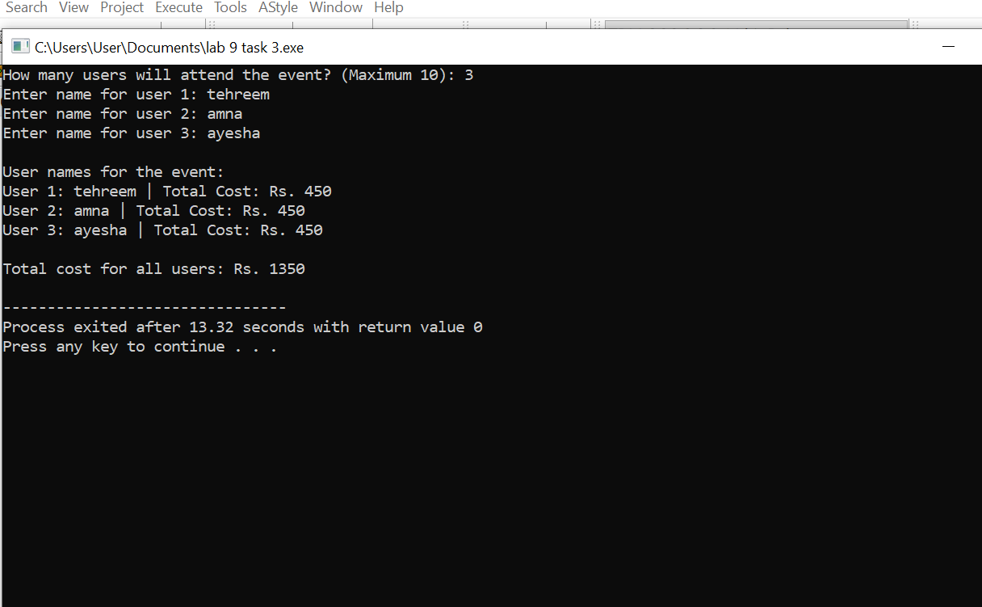

**Qs no .4 Scenario: *Organizing a Game Night* Event**

Imagine you are organizing a game night event for the first-semester students in your college. You want to collect information about the students interested in attending and calculate the entry fee and snack cost.

**Program Start:**

* Initialize two variables, **entryFee** and **snackCost**, to represent the cost of entry and snacks, respectively.

**User Input:**

* The program starts by asking, "How many students will attend the game night? (Maximum 15): "
* The user enters the number of students who want to attend.

**User Input Loop:**

* The program then enters a loop where it asks for the name of each student one by one.
* For example, it might display: "Enter name for student 1: "
* The user inputs the name of the first student and continues until all names are entered.

**Display Student Names:**

* After collecting all the names, the program displays the entered names in the format:

User names for the event:

User 1: [Name1]

User 2: [Name2]

**Maximum Students Check:**

* If the user tries to input more students than the maximum allowed (15 in this case), the program displays an error message: "Error: Not more students allowed."

**Display Student Names and Total Cost:**

* Inside the loop, the program calculates the total cost for each student (entry fee + snack cost) and displays it along with the student's name.

**Display Total Cost:**

* After the loop, the program displays the total cost for all students (entry fee + snack cost).

**Program End:**

* The program ends, and you have successfully gathered the names of students interested in the game night event and the total cost of entry and snacks.

#include <iostream>

#include <vector>

#include <string>

using namespace std;

int main() {

const double entryFee = 5.0;

const double snackCost = 3.0;

const int maxStudents = 15;

int numStudents;

vector<string> studentNames;

cout << "How many students will attend the game night? (Maximum 15): ";

cin >> numStudents;

if (numStudents > maxStudents) {

cout << "Error: Not more students allowed." << endl;

return 1; // Exit the program

}

for (int i = 0; i < numStudents; ++i) {

string name;

cout << "Enter name for student " << (i + 1) << ": ";

cin >> ws;

getline(cin, name);

studentNames.push_back(name);

double totalCostPerStudent = entryFee + snackCost;

cout << "Cost for " << name << ": $" << totalCostPerStudent << endl;

}

cout << "\nUser names for the event:" << endl;

for (size_t i = 0; i < studentNames.size(); ++i) {

cout << "User " << (i + 1) << ": " << studentNames[i] << endl;

}

double totalCost = numStudents * (entryFee + snackCost);

cout << "\nTotal cost for all students: $" << totalCost << endl;

cout << "\nThank you for organizing the game night!" << endl;

return 0;

}

